Dear Parents and Carers

We have made it to the end of a very busy term. I would like to thank you for your continued support and to encourage you to take a look at some of the amazing things the students have participated in this term.
We are very proud of their successes and we look forward to seeing them back in school on Tuesday 6th January 2026

Wishing you all very restful break

Kind regards

Rebecca Williams
Headteacher
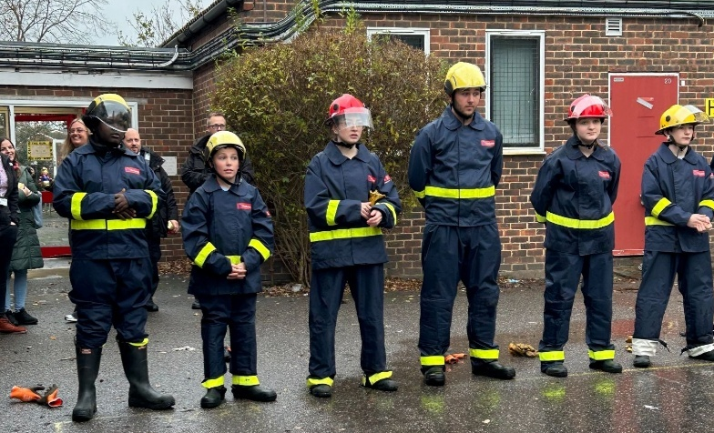
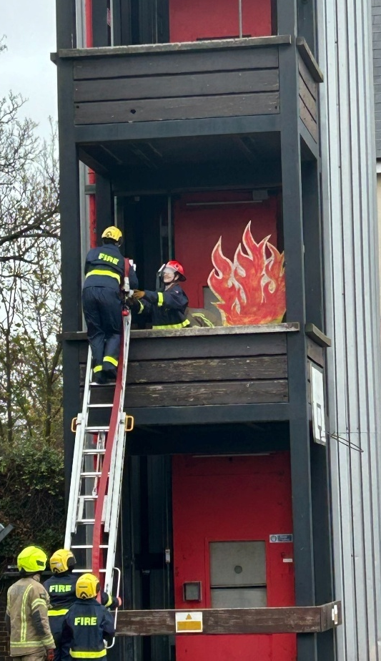

Celebrating Success at the Halo Project in Bexley
We are incredibly proud of our students who took part in the Halo Project event in Bexley. Their commitment, teamwork, and enthusiasm shone throughout the programme, and they impressed everyone with their professionalism and determination.
The highlight of the week was the passing-out parade, where our students received their certificates in recognition of their hard work and achievement. It was a proud moment for all involved, and a testament to their dedication.
Special mention goes to Malachy, whose outstanding performance caught the eye of the fire service – they joked that they would have offered a job on the spot if age wasn’t a factor!

Celebrating Black History Month with a Feast of Flavours!
In October, our school came alive with the vibrant sights, sounds, and tastes of our Food Festival in honour of Black History Month. Pupils, staff, and families enjoyed a delicious journey through traditional dishes and modern twists inspired by African and Caribbean heritage.
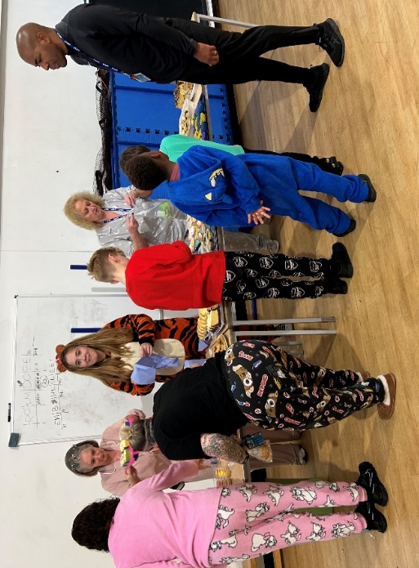
The event wasn’t just about food—it was about community, culture, and learning. From spicy jollof rice to sweet plantain treats, every plate told a story of resilience, creativity, and celebration. Thank you to everyone who contributed to making this festival a truly memorable occasion!

Coming Together for Children in Need
Our school community showed incredible spirit as we joined forces to support Children in Need. From colourful pyjamas to delicious homemade cakes, everyone played a part in making the day special.
Staff, pupils, and families baked, donated, and dressed up, turning fun into fundraising for a fantastic cause. Thanks to your generosity, we’ve helped make a real difference to children who need it most by raising £170.

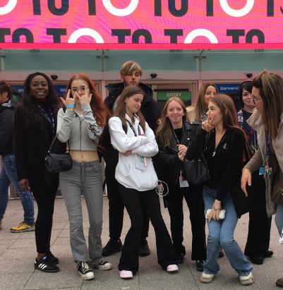
Exploring Creativity at Salon International 2025
Our enrichment trip to Salon International 2025 was an inspiring experience for pupils with a passion for hair and beauty. The event showcased the latest trends, techniques, and innovations from industry leaders, giving students a unique opportunity to learn from professionals and see creativity in action.
From live demonstrations to interactive workshops, the day was packed with ideas and inspiration that will fuel future projects and aspirations. A huge thank you to everyone who made this enriching experience possible!

Primary Visit to Kent Life Museum
Our primary pupils recently enjoyed an enriching visit to Kent Life Museum, bringing their curriculum learning to life. The trip offered a hands-on experience of local history, rural traditions, and heritage crafts. Children explored authentic Victorian homes, discovered farming practices from the past, and engaged in interactive workshops that complemented their classroom topics.
The visit not only deepened their understanding of historical lifestyles but also encouraged curiosity and discussion about how communities have evolved over time. It was a fantastic opportunity to connect learning with real-world experiences, making history tangible and memorable.

Entrepreneurial Skills Put to the Test at Havas International
Our students recently had the exciting opportunity to visit Havas International as part of their work experience programme. The day was designed to challenge and develop their entrepreneurial skills in a real-world setting.
During the visit, pupils engaged in creative workshops, explored marketing strategies, and learned how global campaigns are brought to life. They were tasked with pitching ideas, collaborating in teams, and thinking critically about branding and audience engagement.
This hands-on experience not only strengthened their understanding of business and enterprise but also inspired confidence, creativity, and problem-solving – key skills for future success.

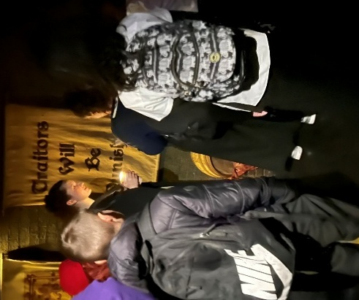
KS4 Curriculum Visit to the London Dungeons
Horizons made history with its first-ever full cohort visit to the London Dungeons, offering all KS4 students a unique opportunity to experience history in an immersive and engaging way. The trip brought the curriculum to life, combining learning with an unforgettable adventure through London’s dark and fascinating past. Students explored interactive exhibits, theatrical performances, and historical narratives that deepened their understanding of key topics while sparking curiosity and discussion.
This inclusive experience marked a significant milestone for Horizons, reinforcing our commitment to providing enriching educational opportunities for every student.

