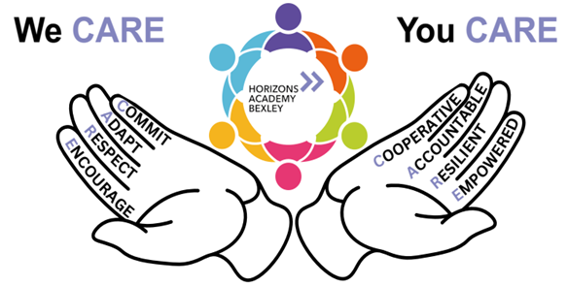

Living Our We CARE / You CARE Values
We have had an exciting and purposeful few weeks at Horizons, filled with activities that truly reflect and strengthen our shared We CARE / You CARE values. I thought I would share with you some of the ways we embody these values.


Jack Petchey Award Trip – Ice Skating at Canary Wharf
Our students proudly used their Jack Petchey Foundation funding to enjoy a fantastic trip to the Canary Wharf ice rink. As they navigated the ice, supported one another, and celebrated their achievements, they demonstrated courage, encouragement, cooperation, and resilience. Students stepped out of their comfort zones and had to adapt their skills. Many students and staff showed respect and encouragement by helping those who were nervous. The cohort held themselves accountable by showcasing excellent behaviour throughout. The trip perfectly captured what it means to feel empowered through new experiences.

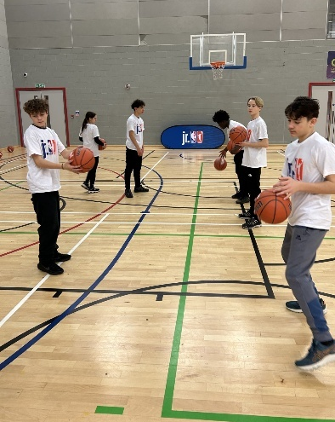
KS3 NBA Coaching Workshop – In Partnership with the VRU and the Halo Project
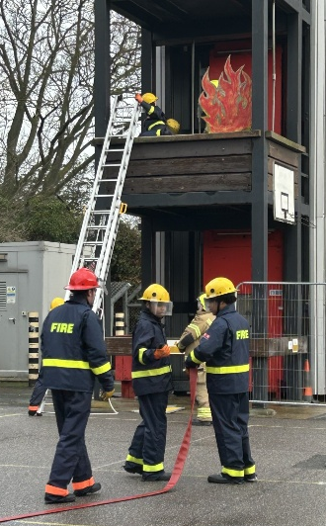
Key Stage 3 students took part in an energising basketball coaching session delivered by NBA-trained coaches which was offered to because of our work with the Violence Reduction Unit. Throughout the session, students learned much more than sport — they developed discipline, teamwork, and perseverance. This opportunity aligned perfectly with our values of commit, cooperate, and resilience, as students pushed themselves physically and mentally while adapting to professional-level coaching. The respect shown to coaches and one another was excellent, and students left feeling empowered to strive for their personal goals.
The students continued to demonstrate our values brilliantly throughout our second opportunity to take part in the Halo Project. They showed commitment by engaging positively, adaptability in embracing new learning experiences, respect for one another and the professionals leading the sessions, and the confidence to grow as young people making safer, informed decisions. We are incredibly proud of how they represented Horizons.

KS4 Careers Input from LSEC
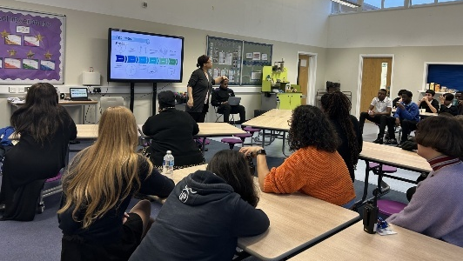
Just before half term Key Stage 4 welcomed visitors from London Southeast Colleges who guided them through post-16 options, career pathways, and courses suited to their skills and interests. Students showed great maturity, asking thoughtful questions and taking ownership of their next steps. This directly reflects the values of accountability, commitment, and empowerment as they begin shaping their future choices. The courteous and engaged discussions demonstrated respect, while their openness to explore different paths showed adaptability and cooperation during the sessions.

Evisense is Launched in Primary
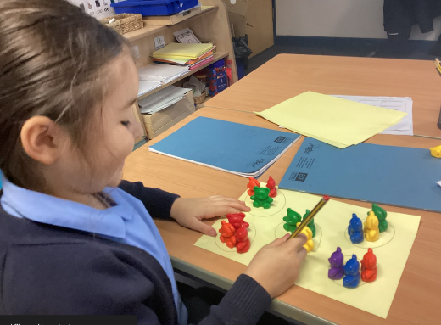
We have introduced Evisense within our Primary phase. This digital platform will enhance communication between home and school. By sharing learning journeys, photos, and progress updates in real time, we are building deeper trust and transparency with our families. This launch strengthens our values of cooperation, respect, and accountability, creating a shared responsibility for each child’s development. Parents are empowered with better insight into their child’s achievements, and staff are committed to enriching communication that encourages ongoing partnership and support.

Academic Review Days – KS3 & KS4
Our Academic Review Days provided valuable opportunities for students and families to reflect on progress, celebrate successes, and set clear targets for the term ahead. The engagement from families reflected our community’s commitment to ensuring every learner succeeds. These conversations modelled accountability, encouraged students to take ownership of their learning, and highlighted the importance of cooperating. Students listened respectfully, adapted their goals where needed, and demonstrated resilience in discussing challenges openly.

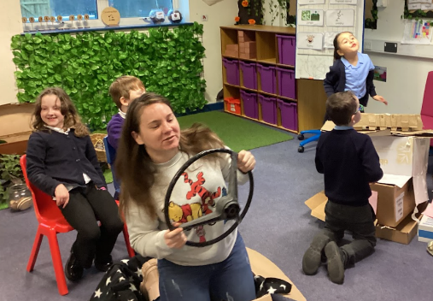
Primary Stay and Play Event
Our Primary Stay and Play event was a great success, bringing families together to share in learning experiences, hands-on activities, and playful moments. Parents and children collaborated beautifully, showing cooperation, respect, and encouragement throughout. This event strengthens our community relationships and supports our ongoing commitment to inclusive family involvement. Children felt empowered, parents appreciated the school’s accountability, and the session demonstrated how adaptable and resilient our youngest learners can be when exploring new activities.

Parent Feedback
We would welcome your feedback. If you have 5 minutes, please follow the link to complete our survey:
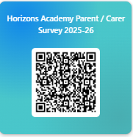

Kind regards
Rebecca Williams
Headteacher

