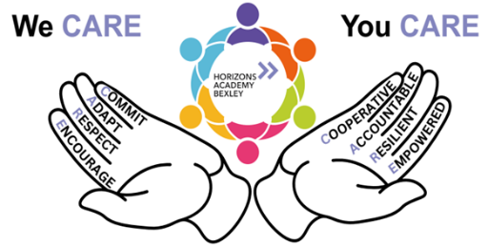

Friday 27th March

Dear Parents and Carers,

As we come to the end of another fast-moving term, it’s hard to believe just how much we’ve managed to fit in. Our students have embraced every opportunity with enthusiasm, and the school has been buzzing with learning, creativity and community spirit.
This week we have been incredibly busy fundraising with our Easter Egg raffle and bake sale, and we are delighted to share that we have raised over £260 for the Laser Foundation. Thank you to everyone who donated, baked, bought tickets, or supported us in any way. We would love to reach our £300 target, so if you are able to make a donation, please do so using:

https://elevaregroup.enthuse.com/pf/horizonsacademy

A special mention goes to our Year 11s, who are deep in preparation for their GCSEs. We are incredibly proud of their focus and resilience, and we continue to support them every step of the way as the exam season approaches.

Thank you, as always, for your ongoing support. It makes such a positive difference to everything we do.

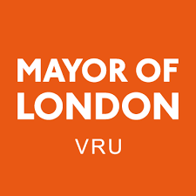
Exciting New Opportunity for Our Students
We are delighted to share that our school has been selected to take part in the Mayor of London’s Violence Reduction Unit Peer Research Project, delivered by Living Proof, a youth-led creative engagement organisation. This is a fantastic opportunity for our young people to have their voices heard and to shape the future of support offered to students across London.
Over the summer term, a small group of our Year 10 and 11 students will take part in weekly workshops where they will learn real research skills—such as interviewing, creative storytelling, film-making, and project design. They will then use these skills to carry out their own peer-research project within school. This is also a paid opportunity, helping to build confidence, responsibility, and valuable experience for their CVs and future pathways.
We are excited to be involved in such a meaningful project that puts young people at the heart of decision-making. It will help our students build communication skills, strengthen relationships, and contribute to positive change both in school and across the wider community. We look forward to celebrating their achievements at the end-of-term showcase event!

Careers Week
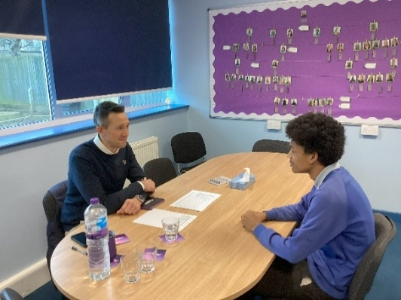
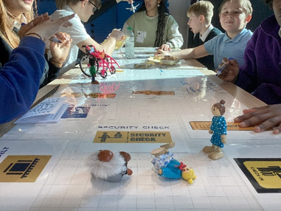
Our students had an exciting and varied Careers Week, taking part in a range of activities designed to inspire their future pathways. KS3 and KS4 students worked with professionals from Finatal, who delivered mock interview sessions that helped them build confidence and develop essential communication skills. They also took part in a CV and self-presentation workshop led by Reed, giving them practical guidance on how to showcase their strengths and experiences. Meanwhile, KS2 and KS3 pupils enjoyed a hands-on STEM Aviation workshop, where facilitators guided them through interactive challenges linked to real careers in the aviation industry. Students were highly engaged, with facilitators praising how well they worked together and their enthusiasm for learning.
Primary pupils also took part in a Dress as Your Future Self Day, arriving at school as future doctors, artists, police officers, chefs, engineers and more. They even had the chance to meet real members of the local police force, who spent time answering questions about life on patrol. The children were fascinated, Jacob in particular asked brilliant questions, including what it was like to go in a fast car! This experience helped bring their aspirations to life, making Careers Week both meaningful and memorable for our youngest learners.
Dino Workshop
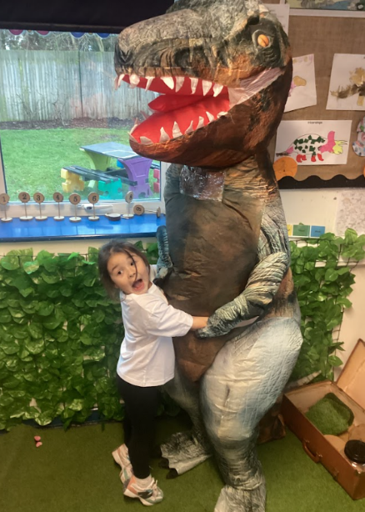
Our Primary pupils worked incredibly hard during the Dino Workshop, fully immersing themselves in each hands-on activity led by the workshop team. They began by carrying out a bubbling science experiment, using pipettes to drop liquid onto “dino eggs” and watching in awe as a chemical reaction slowly revealed the baby dinosaur hidden inside. Their excitement grew as they moved on to becoming real-life archaeologists—carefully brushing through sand to uncover puzzle pieces that they then worked together to build into a complete dinosaur.
To finish, pupils created their very own salt-dough fossils, choosing from dinosaur teeth, bones or even the dinosaur they had just hatched. Throughout the session, they learned fascinating dinosaur facts and developed their teamwork, curiosity and problem-solving skills. This workshop truly brought their learning to life and linked brilliantly with their curriculum topic, giving them an unforgettable experience they were eager to share with staff and families afterwards.
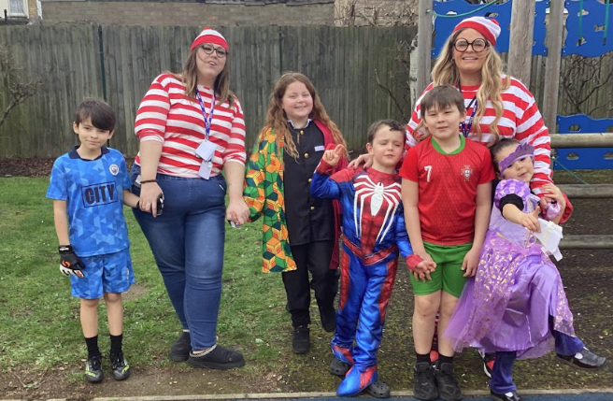
World Book Day
World Book Day was a fantastic celebration across the school, with Primary pupils especially enjoying a magical morning dedicated to reading. The day included a special author visit, where pupils were treated to a live story session and the chance to meet the writer behind the book. This was a wonderful opportunity for our young readers to see stories brought to life and to hear directly from a real author about the joy of writing. Pupils also spent the morning moving through a range of book-themed activities—sensory stories, shared reading with older students, and plenty of chances to enjoy stories together.
Throughout the school, children and staff embraced the spirit of the day by dressing up as their favourite book characters, filling the corridors with colour, creativity, and excitement. To bring everyone together, we ran a lively whole-school reading quiz, where classes competed in a fun Kahoot challenge all about books and characters they love. The buzz of energy and enthusiasm could be felt everywhere, and it was wonderful to see pupils of all ages celebrating reading in such a fun way.

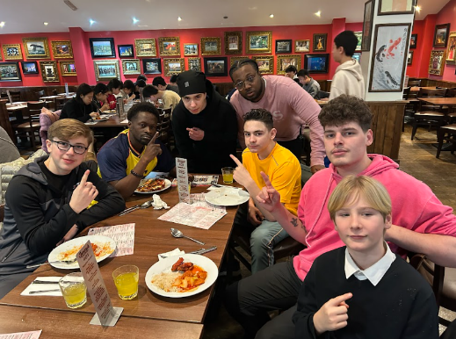
KS3 Enjoy a Fantastic Reward Trip to Jimmy’s Restaurant
Our KS3 pupils rounded off the half-term with a well-deserved reward trip to Jimmy’s Restaurant, where they showcased exceptional behaviour and impeccable manners throughout. The visit offered a wonderful social experience, giving students the chance to spend time together outside the school setting, build confidence in a public environment, and enjoy a shared meal as a celebration of their hard work this term.
Staff were incredibly proud of how maturely and respectfully the pupils conducted themselves—from holding doors for others to engaging kindly with restaurant staff and supporting their peers. It was a pleasure to see students relaxing, laughing, and enjoying each other’s company in such a positive way. Trips like these help reinforce important life skills and remind pupils that their efforts and attitude in school truly do make a difference. Well-done, KS3!
Sky Studio Tour
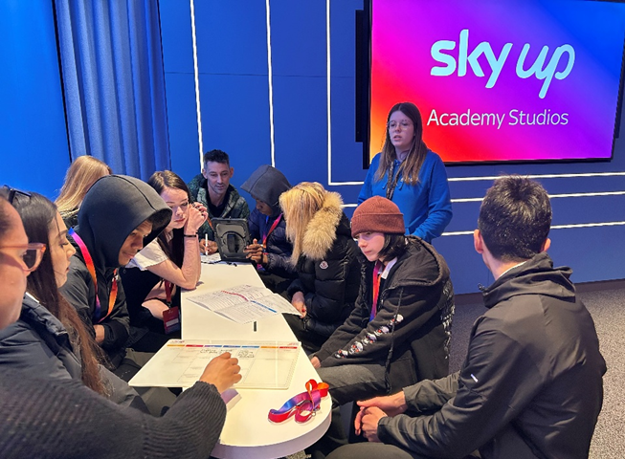
Our KS4 students had an unforgettable experience during their visit to Sky Studios, where they stepped into the world of media production and got a taste of what it’s like to work behind the camera. Supported by staff and guided by the Sky team, students worked in groups to plan, film and produce their own short segments, taking on real industry roles such as presenters, directors, camera operators and editors. The hands-on nature of the workshop enabled them to build teamwork, confidence and communication skills in a professional studio environment.
As part of the day, students were also challenged to pitch their creative ideas, demonstrating imagination and problem-solving as they brought their concepts to life. Staff reported how engaged and enthusiastic pupils were throughout the experience, embracing every element of the fast-paced media world. The visit offered a brilliant opportunity for our young people to explore potential career pathways and understand the wide range of roles within television and film production. A huge thank-you to the team who supported the trip and helped make the day such a memorable success.
Wishing you all a very Happy Easter
Kind regards
Rebecca Williams
Headteacher

