Careers & Transition Policy
academic year 2026-2027



statement Of Intention
It is our aim for every student to complete year 11, prepared for life in modern Britain. This policy framework aims to enhance students’ prospects, encouraging them to contribute to their communities and preparing them for the challenges and opportunities of further education, training and working life including local and national labour market information to reduce their risk of becoming NEET (not in Education, Employment or Training). This will be delivered through a programme of careers education, information, advice and guidance that is in line with the Careers guidance and access for education and training providers guidance
(updated 23 June 2026).

Our Careers policy is set up to provide each student with the skills and confidence to make well
informed decisions regarding their future. We encourage every individual to have high aspirations for themselves and we provide support and encouragement every step of the way.

The Careers Leader at Horizons Academy Bexley is Ms Amie Power.

Delivery
High quality, careers guidance is crucial in helping and ensuring our students emerge from school fully rounded and ready for the world of work. It is our intention to ensure that our students are well-informed when making pathway choices and career decisions.

Impartial advice and guidance sessions are offered to all students that attend Horizons in KS3 at the request from themselves, their parent / carer, or a professional and as a mandatory in KS4. The career sessions are adapted in order to meet students’ individual needs where required. Students will be encouraged to set goals and create personal action plans to support their decision making which is reviewed regularly. The full careers programme will be run for long term students only.

Careers is delivered via:
- Activities during allocated times for all year groups to promote awareness of a wide range of career opportunities and progression routes.
- KS4 Tutor, SEMH (Social, Emotional, Mental Health) Lessons and 1:1 sessions. NCFE Employability, BTEC Personal Growth and Wellbeing Level 1and Kings Trust - Personal Development and Employability Skills Award will be delivered during lessons and tutor times.
- Online Careers education, information & guidance software (Xello).
- Career displays around the schools and in each department area.
- Experiences within working environments / Work Experience.
- Guest speakers.
- Visits to and by local post 16 providers.
- Careers information for parents at Academic Review days.
- Careers action planning – one to one Careers interviews.
- School website has a dedicated Careers area.
- Visits to Career Fairs / relevant events .
- Trips and workshops linking Careers to the curriculum.
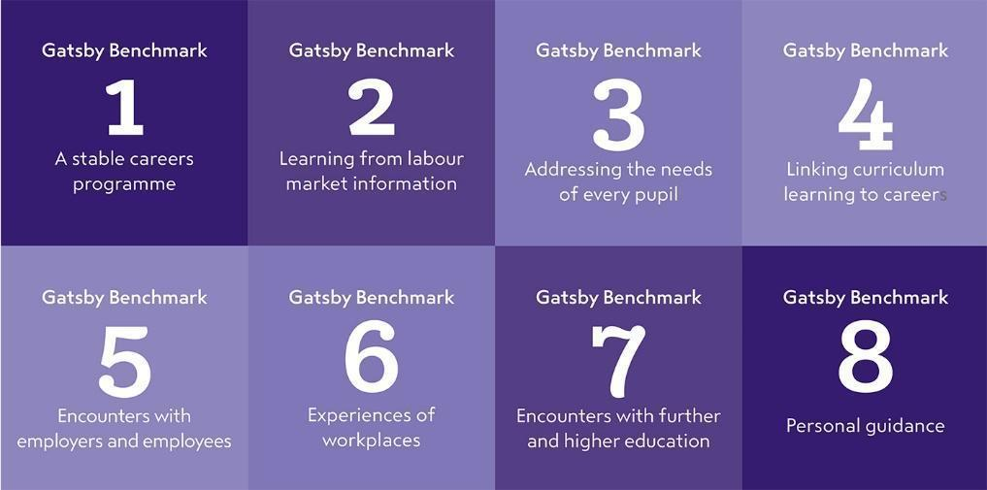
In order to ensure we are compliant with the careers guidance and legal duties we follow the 8 Gatsby Benchmarks with the aim to meet 100% in all 8 areas. The 8 benchmarks are:

Further information regarding the Benchmarks can be found at:
http://www.gatsby.org.uk/education/focus-areas/good-career-guidance
https://assets.publishing.service.gov.uk/government/uploads/system/uploads/attachment_data/file/664319/Careers_strategy.pdf
https://www.gov.uk/government/publications/careers-guidance-provision-for-young-people-in-schools

*Example delivery plan

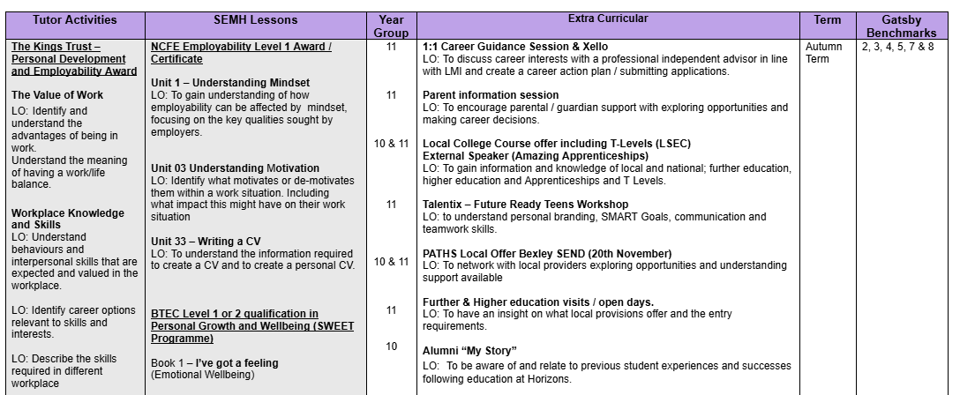

3.0 School responsibility
- To ensure students receive independent and impartial career guidance and advice that covers a wide range of education and training options.
- To provide careers information, labour market information, address stereotypes, identify personal skills and raise aspirations, financial and enterprise awareness throughout the primary and secondary academies through lessons, assemblies, tutor time and/or 1-2-1 sessions.
- To use a variety of methods to engage and inspire students based on their individual learning styles and needs.
- To provide a minimum of two meaningful encounters with further education, higher education (including T Levels), traineeships, apprenticeships and employers.
- To prepare students for the opportunities, responsibilities and experiences of adult life.
- To arm students with careers information in a variety of formats to meet individual needs.
- To enable students to understand and interpret local and national careers information to assist them in making informed choices.
- To help students develop their further education and career awareness to enable them to manage personal career development and make appropriate choices.
- To enable students to manage transitions such as the change from school to further education or to apprenticeships within the workplace.
- To enable Year 10 students to experience the world of work through work experience opportunities.
- To implement long term work placements as part of Personal Learning Plans when required based upon sufficient risk assessments.
- To support students to engage and maintain post statutory placements.
- To introduce and encourage consideration of Apprenticeships, T Levels and University.
- To work with career services within the borough of Bexley.
- To offer and provide independent consistent, robust support and guidance to students, parents/carers and staff.
- To work in liaison with local and national partnership agencies in order to promote Education, Employment and Training (EET) and reduce students who complete their year 11 education at Horizons Academy Bexley from becoming Not in Education, Employment and Training (NEET).
- To continuously monitor its CEIAG offer and seek further improvement. This will be done by the personnel involved in the design and delivery of the programme as well as by external stakeholders who assess the work of the school (eg. School Improvement Partner/Ofsted)

4.0 Post Statutory Support Offer
In line with government guidance’s, Horizons Academy has a responsibility to track destinations of all students who complete their year 11 statutory education within the academy for three years. In addition to this, we offer an innovative voluntary programme where students are able to access support, guidance and advocacy on a 1-2-1 basis at their request.
- All students (16-17 years) are tracked intensely every term (6 Terms) throughout the first academic year post leaving in year 11.
- The second year, all students (17–18 years) will be contacted every other term (3 Terms)
- Within the final third year (18-19 years) young people will be tracked and signposted within the first three terms of the academic year (Sept – Dec). Students may contact the service for support or signposting until the end of the current academic year.
- The careers lead offers support to students that are NEET or at risk of becoming NEET. Students that are EET may also request further support at any point throughout the academic year if and when required.

This process is on a voluntary basis where students must formally sign and agree to work on their behalf for a period of 3 years, with young people having the ability to revoke the agreement at any stage. Equally, the agreement may be terminated should the student not engage with the service and all methods of engagement have been exhausted.
In this scenario, students will be formally informed of this decision and signposted to an alternative support service. The approach the staff take is based upon the positive relationship they have built through the young persons’ statutory education phase and relentless work to engage, reengage and monitor our post statutory students, including conducting home visits, liaising with parents/carers, meeting in mutually agreeable locations and working in a supportive capacity within their placement when required.
The Careers Lead will work in partnership with relevant SEN departments within Local Authorities ensuring students with Education Health Care Plans (EHCP) are completed thoroughly and promptly and shared with proposed Colleges or training providers within specified timeframes (prior to March). It is the responsibility of the Local Authority to ensure consultations take place with providers and to work in partnership with the Careers Lead to ensure providers are named on student’s plans before the end of the academic year. This should be undertaken in a timely manner to prevent our young peoples’ future pathways being negatively affected.

5.0 Partnership working / Stakeholders
Our aim is to ensure students are able to make informed choices that are appropriate and sustainable. In order for this to be achieved, staff are required to have a wide range of local knowledge and excellent professional working relationships both internally and externally. Partners may include, but not limited to;

- Parents/carers
- Bexley & surrounding area Colleges (Kent, Greenwich etc)
- 6th Form Schools
- Bexley Youth Advice
- Bexley SEN Department
- Local Training Providers
- Local/National Employers
- Bexley Children’s Social Care
- Bexley Youth Offending Team
- Community Safety
- Virtual Schools
- School Welfare Officers
- Heads of School
- Local London Careers Hub

The Careers Lead works closely with services commissioned by the Local Authority safeguarding students by sharing destination data which ensures students do not slip through the net and prevents young people from being NEET within the community.

Daily careers education and inspiration is the responsibility of all staff within the academy and we aim to embed a common careers thread through our curriculum. The Careers Lead is responsible for producing and reviewing the annual Careers Delivery Plan for long term students and works in daily partnership with all levels of teaching staff to support the delivery of the careers. The Careers lead works in liaison primarily with our students but also with parents/carers to encourage and support careers choices and improved knowledge.

Horizons Academy advocates work experience opportunities for KS4 students as well as long term work placements when deemed appropriate. Families are informed and communicated with throughout the process and a work experience agreement form and work experience information forms are completed. All students on placement are covered by the employers’ insurance and places of work are risk assessed prior to commencement regarding suitability. Students who do not take part in work experience must attend schools as usual. Staff work collaboratively to ensure safeguarding concerns and risk factors are taken into consideration. Consideration of students individual needs are taken into account in regards to work experience placement and in the event that students are unable to participate in a placement independently, Horizons Academy with endeavour to seek opportunities where students are able to experience working environments via external visits, work shadowing or events to ensure equality of opportunity in line with students needs.
The careers lead will communicate and work with external agencies relating to both statutory and post statutory agencies (post statutory – following consent to share information) with a common aim of working in the students best interest. Additionally when working with post-statutory students, staff will liaise on behalf of the student and/or directly with training providers, colleges and companies in order to prevent students from becoming NEET and to encourage EET.

6.0 Governor Responsibilities
The governing body will ensure that the School has a clear policy on Careers Education, Information and Guidance (CEIAG) and that this is clearly communicated to all stakeholders. They should ensure that this policy is based on the eight Gatsby Benchmarks and is meeting the school’s legal requirements
The governing body will ensure that arrangements are in place to allow a range of educational and training providers to access all students upon request.
There will be a member of the governing body who takes a strategic interest in CEIAG and encourages employer engagement.

7.0 Evaluation, Monitoring & Data
The careers programme is monitored through a range of processes including:
- Careers Development plan
- The use of Career and Enterprise Compass Tool to assess provision against the Gatsby benchmarks. This allows us to quickly and easily assess our strengths and identify areas for improvement.
- Attainment and achievement key indicators
- Post statutory destination sustainability
- NEET / EET Data
- Student, Staff, Parent and external visitor feedback
- Regular meetings with SLT and London Careers Hub.
We provide relevant information about all pupils to local authority support services. This includes:
- basic information such as the pupil’s name, address and date of birth;
- intended post statutory destinations
Data is collected, stored and shared in line with GDPR expectations and guidelines. Data is produced on a termly basis and shared internally with relevant senior members of staff and supports regular Governing Reports. Information requested by children’s/adult social care, police or any statutory agency will be shared accordingly.
Data is produced in quantitative and qualitative formats in order to achieve two principle aims – tracking and learning. Tracking ensures we are providing evidence to support Government expectations and that the design of the service can evolve in order to continually meet the needs of the students.
Statutory Delivery & Engagement Data – Collected Termly (1-6)
Key Stage 4
- 1:1 sessions,
- Workshop / activities,
- Student contact including; home visits, emails and telephone calls.
- External contact; meetings, emails and telephone calls.
- Work experience
- Applications made

Post Statutory Delivery & Engagement Data – Collected Termly (1-6)
Age 16-19 years (3 year post statutory period)
- 1:1 sessions.
- Student contact including; home visits, emails and telephone calls.
- External contact; meetings, emails and telephone calls.
- Current status (EET/NEET) including a brief update summary of support given/offered.

Additional Information
Post Statutory data is also provided in percentages of both NEET and EET students who completed their Year 11 education at Horizons Academy, at the end of each term (1-6).

8.0 Provider Access
Horizons Academy work with providers in order to identify the most effective opportunity for students and share information around the education and training opportunities locally and nationally.
All pupils in years 7-13 are entitled:
- To find out about technical education qualifications and apprenticeships opportunities, as part of our careers programme which provides information on the full range of education and training options available at each transition point.
- To hear from a range of local providers about the opportunities they offer, including technical education and apprenticeships – through options events, assemblies and group discussions and taster events.
- To understand how to make applications for the full range of academic and technical courses.
Appendix 1 outlines the way in which education and training providers should get in touch with us in order to gain access to pupils and/or parents to inform them about further opportunities This complies with the school’s legal obligations under Section 42B of the Education Act 1997.

9.0 Staff CPD
Staff training and CPD needs in relation to CEIAG, are identified and delivered in conjunction with school INSET/CPD schedule and are aligned with the school development plan. This is further supported through performance management and staff appraisals. Staff training and CPD needs are further embedded through daily briefing, newsletters, internal and external meetings, conferences and workshops etc. Careers Leader attends Careers meetings hosted by London Enterprise Advisor Network and other relevant providers.

Document Revision
Date | Who | Description
Sep 2015 | JB | Initial Version
Sep 2016 | JB | Reviewed
Sep 2017 | JB | Reviewed
Dec 2017 | JH | Re-formatted
Dec 2018 | JB & AP | Reviewed
Sep 2019 | JB & AP | Reviewed
Nov 2019 | Governors | Ratified
Dec 2020 | JB & AP | Reviewed
Sep 2021 | AP | Reviewed
Sep 2022 | AP | Reviewed
Sep 2023 | AP | Reviewed
Jan 2023 | AP | Reviewed
Sep 2023 | AP | Reviewed
Sep 2024 | AP | Reviewed
July 2025 | AP | Reviewed
July 2026 | AP | Reviewed

Appendix A - London South East Academy Trust Bexley Provider Access Policy
Rationale
High quality careers education and guidance in school is critical to young people’s futures. It helps to prepare them for the workplace by providing a clear understanding of the world of work including the routes to jobs and careers that they might find engaging and rewarding. It supports them to acquire the self-development and career management skills they need to achieve positive employment destinations. This helps students to choose their pathways, improve their life opportunities and contribute to a productive and successful economy.
As the number of apprenticeships rises every year, it becomes increasingly important that all young people have a full understanding of all the options available to them post-16 including wider technical education options such as T-Levels and Higher Technical Qualifications.
Commitment
Horizons Academy Bexley is committed to ensuring there is an opportunity for a range of education and training providers to access students, for the purpose of informing them about approved technical education qualifications and apprenticeships. We are fully aware of the responsibility to set students on the path that will secure the best outcome which will enable them to progress in education and work and give employers the highly skilled people they need. That means acting impartially, in line with the statutory duty, and not showing bias towards any route, be that academic or technical.
Horizons Academy Bexley endeavours to ensure that all students are aware of all routes to higher skills and are able to access information on technical options and apprenticeships (The Department of Education, July 2021: “Baker Clause”: supporting students to understand the full range of education and training options, and the Provider Access Legislation, January 2023).
Aims
This policy for Access to other education and training providers has the following aims:
- To develop the knowledge and awareness of our students of all career pathways available to them, including technical qualifications and apprenticeships.
- To support young people to be able to learn more about opportunities for education and training outside of school before making crucial choices about their future options.
- To reduce drop out from courses and avoid the risk of students becoming NEET (Young people not in education, employment or training).

Student Entitlement
All Students long term students are entitled to:
- Find out about technical education qualifications and apprenticeships opportunities, as part of a careers programme which provides information on the full range of education and training options available at each transition point;
- Hear from a range of local providers about the opportunities they offer, including technical education and apprenticeships – through options events, assemblies and group discussions and taster events;
- Understand how to make applications for the full range of academic and technical courses.
For pupils of compulsory school age these encounters are mandatory and there will be a minimum of two encounters for pupils during the ‘first key phase’ (year 8 to 9) and two encounters for pupils during the ‘second key phase’ (year 10 to 11).
These provider encounters will be scheduled during the main school hours and the provider will be given a reasonable amount of time to, as a minimum:
- Share information about both the provider and the approved technical education qualification and apprenticeships that the provider offers
- Explain what career routes those options could lead to
- Provide insights into what it might be like to learn or train with that provider (including the opportunity to meet staff and pupils from the provider)
- Answer questions from pupils
Developments & Links with relevant policies
This policy has been developed and is reviewed annually by the Careers Leader and Line Manager based on current good practice guidelines by the Department for Education.
It supports and is underpinned by key school policies including those for Careers, Safeguarding, Equality and Diversity, and SEND which can be found on the schools website.
Equality and Diversity
Access to other providers is available and promoted to allow all students to access information about other providers of further education, apprenticeships and T Levels. Horizons academy is committed to encouraging all students to make decisions about their future based on impartial information.
Request for Access
A provider wishing to request access should contact the Careers Lead:
Amie Power
Telephone: 02083122746
Email: amie.power@horizons.lseat.org.uk
Grounds for Granting Requests for Access
Access will be given for providers to attend during school assemblies, timetabled PSHE / relevant lessons, and Careers or Raising Aspirations events that Horizons Academy is arranging. Students may also travel to visit another provider as part of an external trip and is required to be organised in partnership with Horizons Academy Bexley.
Opportunities for access:
The school offers encounters required by law and a number of additional events which are integrated into the school careers programme.
There is flexibility when scheduling visits, offering providers an opportunity to come into school to speak to pupils or their parents or carers when possible. There is also opportunity for offsite visits to take place providing there is enough notice in order to risk assess and organise travel. We will arrange a visit at the earliest point possible with considerations to student needs, examinations and relevancy. Please find our delivery programme plan on the website for full details.
https://horizons.lseat.org.uk/school-information/172-careers-transition
Please speak to our Careers Lead to identify the most suitable opportunity for you.

Details of Premises or Facilities
Horizons Academy Bexley will provide an appropriate room or assembly hall which will be agreed in advance. Computers and screens can be accessed upon request. The Careers Leader or member of SLT will organise this, working closely with the provider to ensure the facilities are appropriate to the audience. Appropriate safeguarding checks will be carried out and visitors will be informed of how the event will run keeping students individual needs at the centre. Providers will be met and supervised by a member of staff who will facilitate.
Live / Virtual Encounters
Horizons Academy Bexley will consider live online encounters with providers where requested, and these may be broadcast into classrooms or the school assembly hall. Technology checks in advance will be required to ensure compatibility of systems.
Parents and Carers
Parental involvement is encouraged, and parents may be invited to attend the events to meet the providers if required or requested.

Management
The Careers Leader coordinates all provider requests and is line managed by a member of the Senior Leadership Team.

Complaints Procedure
Any complaints about this policy should be raised to the Head Teacher;
email: rebecca.williams@horizons.lseat.org.uk

Monitoring review and evaluation
The Policy is monitored and evaluated annually by the Head Teacher.
Policy Reviewed: September 2025

Previous providers
Providers who have previously delivered meaningful encounters at Horizons Academy include:
- DWP Job Centre Plus
- Ask Apprenticeships
- London South East Colleges
- Shooters Hill Sixth Form College
- Mace
- London Fire Brigade
- British Army
- Metropolitan Police
- Hub 4 Youths

Destinations of our pupils
Last year our year 11 pupils moved to range of providers in the local area after school for example, but not limited to:
- London South East Colleges
- Shooters Hill Sixth Form
- Access to Music
- North Kent College
- Capel Manor College

