Careers & Transition Policy

academic year 2024-2025



# statement Of Intention

It is our aim for every student to complete year 11, prepared for life in modern Britain. This policy framework aims to enhance students’ prospects, encouraging them to contribute to their communities and preparing them for the challenges and opportunities of further education, training and working life including local and national labour market information to reduce their risk of becoming NEET (not in Education, Employment or Training). This will be delivered through a programme of careers education, information, advice and guidance that is in line with the updated Statutory Careers Guidance for Schools (updated January 2023).

Our Careers policy is set up to provide each student with the skills and confidence to make well

informed decisions regarding their future. We encourage every individual to have high aspirations for themselves and we provide a support and encouragement every step of the way.

The Careers Leader at Horizons Academy Bexley is Ms Amie Power.

# Delivery

High quality, careers guidance is crucial in helping and ensuring our students emerge from school fully rounded and ready for the world of work. It is our intention to ensure that our students are well-informed when making pathway choices and career decisions.

Impartial advice and guidance sessions are offered to all students that attend Horizons in KS3 & KS4 and are adapted in order to meet students’ individual needs where required. Students will be encouraged to set goals and create a personal action plans to support their decision making which is reviewed regularly. The full careers programme will be run for long term students only. We also aim to introduce a variety of careers and challenging stereotypes to KS2 in order to raise aspirations.

Careers is delivered via:

* PSHE Lessons in KS2 & KS3 and via Employability lessons in KS4.
* Activities during allocated times for all year groups to promote awareness of a wide range of career opportunities and progression routes.
* Career displays around the schools and in each department area.
* Work Experience
* Guest speakers
* Visits to and by local post 16 providers
* Careers information for parents at Academic Review days
* Careers action planning – one to one Careers interviews
* School website has a dedicated Careers area.
* Visits to Career Fairs

In order to ensure we are compliant with the careers guidance and legal duties we follow the 8 Gatsby Benchmarks with the aim to meet 100% in all 8 areas. The 8 benchmarks are:

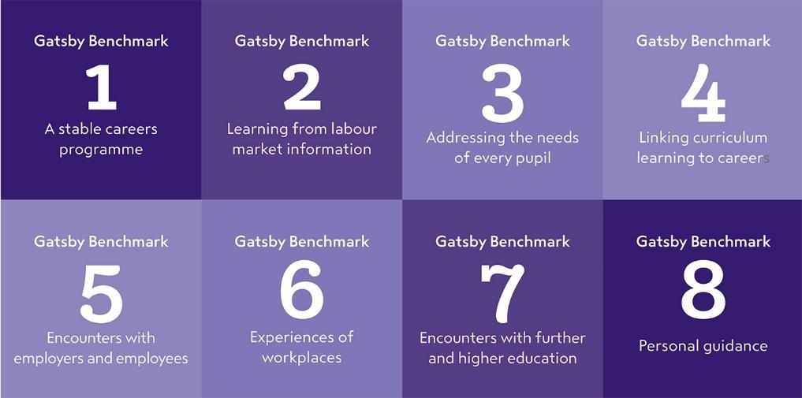

Further information regarding the Benchmarks can be found at:

<http://www.gatsby.org.uk/education/focus-areas/good-career-guidance>

<https://assets.publishing.service.gov.uk/government/uploads/system/uploads/attachment_data/file/664319/Careers_strategy.pdf>

<https://www.gov.uk/government/publications/careers-guidance-provision-for-young-people-in-schools>

*Example delivery plan

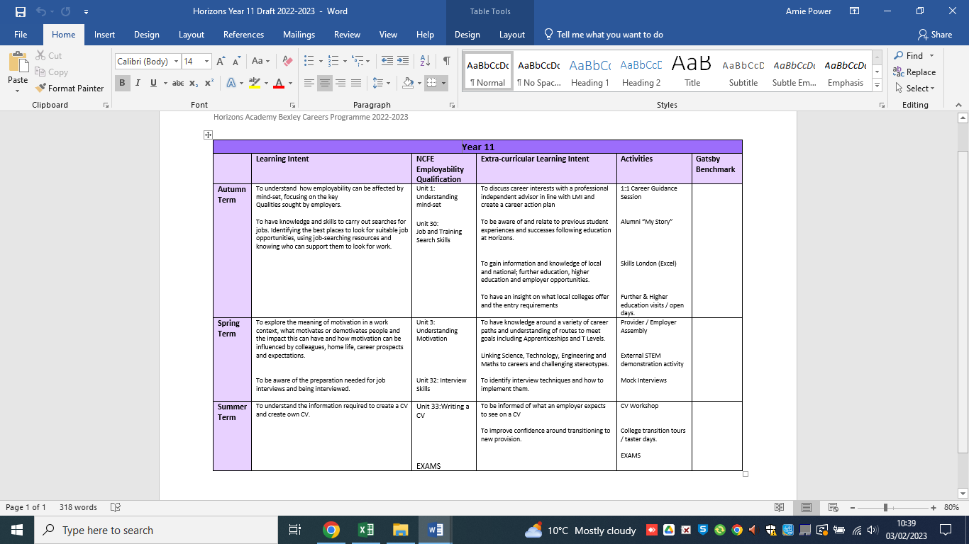

## 3.0 School responsibility

* To ensure students receive independent and impartial career guidance and advice that covers a wide range of education and training options.
* To provide careers, financial and enterprise awareness throughout the primary and secondary academies through lessons, assemblies, tutor time and/or 1-2-1 sessions.
* To use a variety of methods to engage and inspire students based on their individual learning styles and needs.
* To provide a minimum of two meaningful encounters with further education, higher education (including T Levels), traineeships, apprenticeships and employers.
* To prepare students for the opportunities, responsibilities and experiences of adult life.
* To arm students with careers information in a variety of formats to meet individual needs.
* To enable students to understand and interpret local and national careers information to assist them in making informed choices.
* To help students develop their further education and career awareness to enable them to manage personal career development and make appropriate choices.
* To enable students to manage transitions such as the change from school to further education or to apprenticeships within the workplace.
* To enable Year 10 students to experience the world of work through our Work Experience offer.
* To implement long term work placements as part of Personal Learning Plans when required based upon sufficient risk assessments, (year 10 1 day per week, year 11 2 days per week only).
* To support students to engage and maintain post statutory placements.
* To introduce and encourage consideration of Apprenticeships, T Levels and University.
* To work with Prospects, as the Bexley SEN commissioned service.
* To offer and provide independent consistent, robust support and guidance to students, parents/carers and staff.
* To provide staff with access to resources to support the delivery of career related lessons and any relevant qualifications.
* To work in liaison with local and national partnership agencies in order to promote Education, Employment and Training (EET) and reduce students who complete their year 11 education at one of our Academies from becoming Not in Education, Employment and Training (NEET).
* To continuously monitor its CEIAG offer and seek further improvement. This will be done by the personnel involved in the design and delivery of the programme as well as by external stakeholders who assess the work of the school (eg. School Improvement Partner/Ofsted)

## 4.0 Post Statutory Support Offer

As part of the Careers Strategy 2017 and the 8 Gatsby Benchmarks 2018, there is a responsibility to support, track and monitor all students who complete their year 11 statutory education within the academy for three years. We offer an innovative voluntary programme where students are offered intense support, guidance and advocacy in group and 1-2-1 settings.

* All students (16-17 years) are tracked and are supported intensely every term (6 Terms) throughout the first academic year post leaving in year 11.
* The second year, all students (17–18 years) will be contacted every other term (3 Terms) providing intense support to students that are NEET or at High risk of becoming NEET. Students that are EET may also request further support at any point throughout the academic year if required.
* Within the final third year (18-19 years) young people will be tracked and signposted within the first three terms of the academic year (Sept – Dec). Students may contact the service for support or signposting until the end of the current academic year however; the intensity of support will be decreased in order to encourage independence.

This process is on a voluntary basis where students must formally sign and agree us to work on their behalf for a period of 3 years, with young people having the ability to revoke the agreement at any stage. Equally, the agreement may be terminated should the student not engage with the service and all methods of engagement have been exhausted.

In this scenario, students will be formally informed of this decision and signposted to an alternative support service. The approach the staff take is based upon the positive relationship they have built through the young persons’ statutory education phase and relentless work to engage, reengage and monitor our post statutory students, including conducting home visits, liaising with parents/carers, meeting in mutually agreeable locations and working in a supportive capacity within their placement when required.

The Careers Lead will work in partnership with relevant SEN departments within Local Authorities ensuring students with Education Health Care Plans (EHCP) are completed thoroughly and promptly and shared with proposed Colleges or training providers within specified timeframes (prior to March). It is the responsibility of the Local Authority to ensure consultations take place with providers and to work in partnership with the Careers Lead to ensure providers are named on student’s plans before the end of the academic year. This should be undertaken in a timely manner to prevent our young peoples’ future pathways being negatively affected.

## 5.0 Partnership working / Stakeholders

Our aim is to ensure student‘s are able to make informed choices that are appropriate and sustainable. In order for this to be achieved, Careers & Transition staff are required to have a wide range of local knowledge and excellent professional working relationships both internally and externally. Partners may include, but not limited to;

* Parents/carers
* Bexley & surrounding area Colleges (Kent, Greenwich etc)
* 6th Form Schools
* Prospects (Independent Careers Advisers)
* Bexley SEN Department
* Local Training Providers
* Local/National Employers
* Bexley Children’s Social Care
* Bexley Youth Offending Team
* Community Safety
* Virtual Schools
* School Welfare Officers
* Heads of School
* Local London Careers Hub

The Careers and Transition staff work closely with services commissioned by the Local Authority safeguarding students by sharing destination data which ensures students do not slip through the net and prevents young people from being NEET within the community.

Daily careers education and inspiration is the responsibility of all staff within the academy and we aim to embed a common careers thread through our curriculum. The Careers Lead is responsible for producing and reviewing the annual Careers Delivery Plan for both statutory and post statutory students and work in daily partnership with all levels of teaching staff to support the delivery of the careers lessons. As part of the aim to achieve the 8 Gatsby Benchmarks, staff will liaise directly with local and national companies in order to gain working agreements to support the careers advice and guidance. The Careers lead works in liaison primarily with our students but also with parents/carers to encourage and support careers choices and improved knowledge.

Horizons Academy advocate work experience opportunities for KS4 student’s as well as long term work placements when deemed appropriate. Families are informed and communicated with throughout the process and a work experience agreement form and work experience information forms are completed. All students on placement are covered by the employers’ insurance and places of work are risk assessed prior to commencement regarding suitability. Students who do not take part in work experience must attend schools as usual. Staff work collaboratively to ensure safeguarding concerns and risk factors are taken into consideration and work is delivered in line with this consideration and Working Together to Safeguard Children July 2018 (updated 2022). The careers lead will communicate and work with external agencies relating to both statutory and post statutory agencies (post statutory – following consent to share information) with a common aim of working in the students best interest. Additionally when working with post-statutory students, staff will liaise on behalf of the student and/or directly with training providers, colleges and companies in order to prevent students from becoming NEET and to encourage EET.

## 6.0 Governor Responsibilities

The governing body will ensure that the School has a clear policy on Careers Education, Information and Guidance (CEIAG) and that this is clearly communicated to all stakeholders. They should ensure that this policy is based on the eight Gatsby Benchmarks and is meeting the school’s legal requirements

The governing body will ensure that arrangements are in place to allow a range of educational and training providers to access pupils in Years 7 – 11.

There will be a member of the governing body who takes a strategic interest in CEIAG and encourages employer engagement.

## 7.0 Evaluation, Monitoring & Data

The careers programme is monitored through a range of processes including:

* Careers Development plan
* The use of Career and Enterprise Compass Tool to assess provision against the Gatsby benchmarks. This allows us to quickly and easily assess our strengths and identify areas for improvement.
* Attainment and achievement key indicators
* Post statutory destination sustainability
* NEET / EET Data
* Student, Staff, Parent and external visitor feedback
* Regular meetings with SLT and London Careers Hub.

As stated in the Statutory Careers guidance for governing bodies, school leaders and school staff October 2018. We provide relevant information about all pupils to local authority support services. This includes:

1. basic information such as the pupil’s name, address and date of birth;
2. intended post statutory destinations

Data is collected, stored and shared in line with GDPR 2018 expectations and guidelines. Data is produced on a termly basis and shared internally with relevant senior members of staff and supports regular Governing Reports which is shared with the Board. Information requested by children’s/adult social care, police or any statutory agency will be shared accordingly.

Data is produced in quantitative and qualitative formats in order to achieve two principle aims – tracking and learning. Tracking ensures we are providing evidence to support Government expectations and that the design of the service can evolve in order to continually meet the needs of the students.

|  |
| --- |
| Statutory Delivery & Engagement Data – Collected Termly (1-6) |
| Key Stage 4 |
| * 1:1 sessions, * Workshop / activities, * Student contact including; home visits, emails and telephone calls. * External contact; meetings, emails and telephone calls. * Work experience * Applications made |

|  |
| --- |
| Post Statutory Delivery & Engagement Data – Collected Termly (1-6) |
| Age 16-19 years (3 year post statutory period) |
| * 1:1 sessions, * Workshop / activities, * Student contact including; home visits, emails and telephone calls. * External contact; meetings, emails and telephone calls. * Current status (EET/NEET) including a brief update summary of support given/offered. |
| Additional Information |
| Post Statutory data is also provided in percentages of both NEET and EET students who completed their Year 11 education at Horizons Academy, at the end of each term (1-6). |

## 8.0 Provider Access

Horizons Academy work with providers in order to identify the most effective opportunity for students and share information around the education and training opportunities locally and nationally.

All pupils in years 7-13 are entitled:

- To find out about technical education qualifications and apprenticeships opportunities, as part of our careers programme which provides information on the full range of education and training options available at each transition point.

- To hear from a range of local providers about the opportunities they offer, including technical education and apprenticeships – through options events, assemblies and group discussions and taster events.

- To understand how to make applications for the full range of academic and technical courses.

Appendix 1 outlines the way in which education and training providers should get in touch with us in order to gain access to pupils and/or parents to inform them about further opportunities This complies with the school’s legal obligations under Section 42B of the Education Act 1997.

## 9.0 Staff CPD

Staff training and CPD needs in relation to CEIAG, are identified and delivered in conjunction with school INSET/CPD schedule and are aligned with the school development plan. This is further supported through performance management and staff appraisals. Staff training and CPD needs are further embedded through daily briefing, newsletters, internal and external meetings, conferences and workshops etc. Careers Leader attends Careers meetings hosted by London Enterprise Advisor Network and other relevant providers.

## 10.0 National Lockdown / COVID 19

The delivery of Careers Information Advice and Guidance will be adapted and delivered virtually in the event of a national lockdown that requires a blended learning approach. The delivery focus may vary but will be aimed at those with the highest risk of imminent impact for example; students with EHC Plans, students deemed vulnerable and those that are highest risk of becoming NEET.

The local and National Labour Market information will be considered and shared with students when working under such restrictions to highlight the impact and changes to allowing informed decisions to be made.

The delivery will reflect the current safeguarding guidance during any lockdown period.

Relevant information on the changes made by government that impact on the delivery of Careers Information Advice and Guidance will also be published on the schools website:

<https://horizonsbexley.org.uk/horizons/home/careers-transition>

Document Revision

|  |  |  |
| --- | --- | --- |
| Date | Who | Description |
| Sep 2015 | JB | Initial Version |
| Sep 2016 | JB | Reviewed |
| Sep 2017 | JB | Reviewed |
| Dec 2017 | JH | Re-formatted |
| Dec 2018 | JB & AP | Reviewed |
| Sep 2019 | JB & AP | Reviewed |
| Nov 2019 | Governors | Ratified |
| Dec 2020 | JB & AP | Reviewed |
| Sep 2021 | AP | Reviewed |
| Sep 2022 | AP | Reviewed |
| Sep 2023 | AP | Reviewed |
| Jan 2023 | AP | Reviewed |
| Sep 2023 | AP | Reviewed |
| Sep 2024 | AP | Reviewed |

**Appendix A - London South East Academy Trust Bexley Provider Access Policy**

**Introduction**

This policy statement sets out the Academies arrangements for managing the access of providers to Students at Horizons Academy Bexley, for the purpose of giving them information about the provider’s education or training offer. This complies with the Academies legal obligations under Section 42B of the Education Act 1997.

**Student Entitlement**

All Students in years 8-11 are entitled:

• To find out about technical education qualifications and apprenticeships opportunities, as part of a careers programme which provides information on the full range of education and training options available at each transition point;

• To hear from a range of local providers about the opportunities they offer, including technical education and apprenticeships – through options events, assemblies and group discussions and taster events;

• To understand how to make applications for the full range of academic and technical courses.

For pupils of compulsory school age these encounters are mandatory and there will be a minimum of two encounters for pupils during the ‘first key phase’ (year 8 to 9) and two encounters for pupils during the ‘second key phase’ (year 10 to 11).

These provider encounters will be scheduled during the main school hours and the provider will be given a reasonable amount of time to, as a minimum:

• share information about both the provider and the approved technical

education qualification and apprenticeships that the provider offers

• explain what career routes those options could lead to

• provide insights into what it might be like to learn or train with that provider (including the opportunity to meet staff and pupils from the provider)

• answer questions from pupils

**Equality and Diversity**

Access to other providers is available and promoted to allow all students to access information about other providers of further education, apprenticeships and T Levels. Horizons academy is committed to encouraging all students to make decisions about their future based on impartial information.

**Meaningful Provider Encounters**

One encounter is defined as one meeting/session between pupils and one provider. We are committed to providing meaningful encounters to all pupils using the CEC Making it meaningful checklist.

Meaningful online engagement is also an option, and we are open to providers that are able to provide live online engagement with our pupils. Technology requirements and testing will be arranged prior to agreement.

**Previous providers**

Providers who have been invited into/ delivered meaningful encounters at Horizons Academy include:

* DWP Job Centre Plus

MACE

London Fire Brigade

British Army

Middleton Murray

* Glam Sci
* Ask Apprenticeships
* London South East Colleges
* Shooters Hill Sixth Form College

**Destinations of our pupils**

Last year our year 11 pupils moved to range of providers in the local area after school for example, but not limited to:

London South East Colleges

Shooters Hill Sixth Form

Access to Music

North Kent College

Capel Manor College

The BRIT School

**Opportunities For Access:**

The school offers encounters required by law and a number of additional events which are integrated into the school careers programme.

There is flexibility when scheduling visits, offering providers an opportunity to come into school to speak to pupils or their parents or carers when possible. There is also opportunity for offsite visits to take place providing there is enough notice in order to risk assess and organise travel. We will arrange a visit at the earliest point possible with considerations to student needs, examinations and relevancy. Please find our delivery programme plan on the website for full details.

<https://horizons.lseat.org.uk/school-information/172-careers-transition>

Please speak to our Careers Lead to identify the most suitable opportunity for you.

**Premises and Facilities**

The Academy will make the hall, classrooms or private meeting rooms available for discussions between the provider and students, as appropriate to the activity and in line with student’s individual needs. The Academy will endeavour to support the providers technical requirements such as AV for presentations, this will all be discussed and agreed in advance of the visit with the Careers & Transition Coordinator or a member of their team.

**Provider Access Requests Procedure:**

A provider wishing to request access should contact the Careers Lead:

**Amie Power**

**Telephone:** 02083122746

**Email:** [amie.power@horizons.lseat.org.uk](mailto:amie.power@newhorizonsfederation.org.uk)

**Complaints Procedure**

Any complaints about this policy should be raised to the Head Teacher;

email: [grant.monaghan@horizons.lseat.org.uk](mailto:grant.monaghan@horizons.lseat.org.uk)